**Department of CSE(Artificial Intelligence and Machine Learning)**

**III Year II Semester**

**Employability Skills - II (BusinessAnalytics using Tableau)**

**UNIT 1 : Introduction to Tableau & Data Visualization**

1. Introduction to Tableau
2. Tableau Architecture
3. Tableau Prep
   1. Introduction to Tableau Prep
   2. Tableau Prep Builder User Interface
4. Data Visualization
5. Tableau Tools
6. Tableau Desktop Installation
7. Business Intelligence Tools
8. **Introduction to Tableau**

**Tableau** is a powerful tool used for data analysis and visualization. It allows the creation of amazing and interactive visualization and that too without coding. Tableau is very famous as it can take in data and produce the required [**data visualization**](https://www.geeksforgeeks.org/what-is-data-visualization-and-why-is-it-important/) output in a very short time. Basically, it can elevate your data into insights that can be used to drive your action in the future.

Tableau is a visual analytics platform that is revolutionizing the way we use data to solve problems by enabling individuals and organisations to make the most of their data.Tableau is a great data visualization and business intelligence application that can be used to report and analyse massive amounts of data. Salesforce purchased Tableau in June 2019, an American firm founded in 2003. It enables users to build various charts, graphs, maps, dashboards, and stories for visualising and analysing data in order to aid in business choices. Tableau offers several unique and fascinating features that make it one of the most popular business intelligence (BI) applications.

Tableau is the fastest and most powerful visualization tool. It is very easy to use. There are no complex formulas like Excel and other visualization tools. It provides the features like cleaning, organizing, and visualizing data, it easier to create interactive visual analytics in the form of dashboards. These dashboards make it easier for non-technical analysts and end-users to convert data into understandable ones.

As a leading data visualization tool, Tableau has many desirable and unique features. Its powerful data discovery and exploration application allows you to answer important questions in seconds. You can use Tableau's drag and drop interface to visualize any data, explore different views, and even combine multiple databases easily. It does not require any complex scripting. Anyone who understands the business problems can address it with a visualization of the relevant data. After analysis, sharing with others is as easy as publishing to Tableau Server.

**Features of Tableau**

* Tableau supports powerful data discovery and exploration that enables users to answer important questions in seconds
* No prior programming knowledge is needed; users without relevant experience can start immediately with creating visualizations using Tableau
* It can connect to several data sources that other BI tools do not support. Tableau enables users to create reports by joining and blending different datasets
* Tableau Server supports a centralized location to manage all published data sources within an organization

**Values in Tableau**

There are two types of values in the tableau:

* **Dimensions:** Values that are discrete(which can not change with respect to time) in nature called Dimension in tableau. Example: city name, product name, country name.
* **Measures:**Values that are continuous(which can change with respect to time) in nature called Measure in tableau. Example: profit, sales, discount, population.

**Advantages of Tableau**

* **Quick calculation-** All the calculations on the tableau done by the backend, so it is relatively faster than any other tool.
* **Interactive dashboards**– Tableau dashboards are very interactive and easy to draw.
* **No manual calculation-**All the calculations are done by the tableau only. There is no manual calculation, but in some specific cases, we used calculated fields for calculation.
* **A large amount of data-**Tableau can handle a large amount of data. Different types of visualization can be created with a large amount of data without impacting the performance of the dashboards.

**Disadvantages of Tableau**

* **High Cost-** tableau is a paid tool for visualization, and it is a reason why people are not using tableau so much.
* **Static and single value parameters-**Tableau’s parameters are static and always single value can be selected using a parameter. Whenever the data gets changed, these parameters need to be updated manually every time.
* **Limited Data Preprocessing-**Tableau is strictly a visualization tool. Tableau Desktop allows you to do very basic preprocessing.

1. **Tableau Architecture**

Tableau Server is designed to connect many data tiers. It can connect clients from Mobile, Web, and Desktop. Tableau Desktop is a powerful data visualization tool. It is very secure and highly available. It can run on both the physical machines and virtual machines. It is a **multi-process**, **multi-user**, and **multi-threaded** system.

Providing such powerful features requires unique architecture.The different layers used in Tableau server are given in the following architecture diagram:-

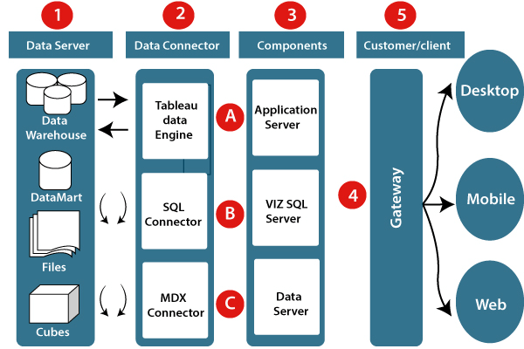

**Different components of the Tableau architecture:**

**1. Data server:-** The primary component of Tableau Architecture is the Data sources which can connect to it.

Tableau can connect with multiple data sources. It can blend the data from various data sources. It can connect to an **excel file, database**, and a **web application** at the same time. It can also make the relationship between different types of data sources.

**2. Data connector:-** The Data Connectors provide an interface to connect external data sources with the Tableau Data Server.

Tableau has in-built SQL/ODBC connector. This ODBC Connector can be connected with any databases without using their native connector. Tableau desktop has an option to select both extract and live data. On the uses basis, one can be easily switched between live and extracted data.

* **Real-time data or live connection:** Tableau can be connected with real data by linking to the external database directly. It uses the infrastructure existing database by sending dynamic **multidimensional expressions (MDX)** and SQL statements. This feature can be used as a linking between the live data and Tableau rather than importing the data. It makes optimized and a fast database system. Mostly in other enterprises, the size of the database is large, and it is updated periodically. In these cases, Tableau works as a front-end visualization tool by connecting with the live data.
* **Extracted or in-memory data:** Tableau is an option to extract the data from external data sources. We make a local copy in the form of Tableau extract file. It can remove millions of records in the Tableau data engine with a single click. Tableau's data engine uses storage such as **ROM, RAM**, and **cache** memory to process and store data. Using filters, Tableau can extract a few records from a large dataset. This improves performance, especially when we are working on massive datasets. Extracted data allows the users to visualize the data offline, without connecting to the data source.

**3. Components of Tableau server:** Different types of component of the Tableau server are:

*Application server*

*VizQL server*

*Data server*

**A. Application server:** The application server is used to provide the authorizations and authentications. It handles the permission and administration for mobile and web interfaces. It gives a guarantee of security by recording each session id on Tableau Server. The administrator is configuring the default timeout of the session in the server.

**B. VizQL server:** VizQL server is used to convert the queries from the data source into visualizations. Once the client request is forwarded to the VizQL process, it sends the query directly to the data source retrieves information in the form of images. This visualization or image is presented for the users. Tableau server creates a cache of visualization to reduce the load time. The cache can be shared between many users who have permission to view the visualization.

**C. Data server:** Data server is used to store and manage the data from external data sources. It is a central data management system. It provides data security, metadata management, data connection, driver requirements, and data storage. It stores the related details of data set like calculated fields, metadata, groups, sets, and parameters. The data source can extract the data as well as make live connections with external data sources.

**4. Gateway:** The gateway directed the requests from users to Tableau components. When the client sends a request, it is forwarded to the external load balancer for processing. The gateway works as a distributor of processes to different components. In case of absence of external load balancer, the gateway also works as a load balancer. For single server configuration, one gateway or primary server manages all the processes. For multiple server configurations, one physical system works as a primary server, and others are used as worker servers. Only one machine is used as a primary server in Tableau Server environment.

**5. Clients:** The visualizations and dashboards in Tableau server can be edited and viewed using different clients. Clients are **a web browser, mobile applications**, and **Tableau Desktop**.

* **Web Browser:** Web browsers like **Google Chrome, Safari**, and **Firefox** support the Tableau server. The visualization and contents in the dashboard can be edited by using these web browser.
* **Mobile Application:** The dashboard from the server can be interactively visualized using mobile application and browser. It is used to edit and view the contents in the workbook.
* **Tableau Desktop:** Tableau desktop is a business analytics tool. It is used to **view, create**, and **publish** the dashboard in Tableau server. Users can access the various data source and build visualization in Tableau desktop.

1. **(a) Introduction to Tableau Prep**

Before doing data analysis with Tableau, data cleaning is of utmost importance and very crucial. This is what ***Tableau Prep*** as a tool does. This tool from Tableau helps transform, clean, and shape the data for analysis quickly.

Tableau Prep helps with the cleaning, shaping, and organization of data before it can be analyzed. It can gather a considerable amount of data from varied sources and transform them. Its simple drag-and-drop features quickly streamline the complicated tasks of pivots, unions, joins, aggregate, etc. Once the data is clean, it can be subsequently used in the Tableau Prep output as the data source for [**Tableau**](https://intellipaat.com/blog/what-is-tableau/) Desktop for analysis.

There are sample datasets included in Tableau Prep like the **Sample Superstore** that you can use to create a flow for Please note that the latest version of Tableau Prep Builder will be used here.Results may vary for previous versions.

## ****Tableau Prep Builder Download and Installation :****

To download and install Tableau Prep Builder, you will need a Creator product key and the installer. Go to the [**Customer Portal**](https://buy.tableau.com/on/demandware.store/Sites-TableauCommerce-Site/en_US/ContactUs-ContactSales)for the most latest and updated version of Tableau Prep Builder.The installer can be downloaded from the Product Downloads section according to your operating system. You will get the installers from the [**Product Downloads and Release Notes**](https://www.tableau.com/support/releases)page. There is also a [**free trial**](https://www.tableau.com/products/prep/download)version available.Please note that Tableau Prep Builder is specifically built to work with Tableau Desktop. So, make sure to install it on the same system that runs Tableau Desktop and not the one that is running [**Tableau Server**](https://intellipaat.com/blog/what-is-tableau-server/). Tableau Server Resource Manager (SRM) cannot differentiate between the Tableau Prep protocol server process and the Tableau Server protocol server process. SRM may end the protocol server process of Tableau Prep Builder in case the computer resources are exhausted, and this does not have a recovery mechanism.

Tableau Prep Builder automatically creates a My Tableau <application> Repository folder structure in the documents folder. If you want to move this repository to another location, you can specify the desired location and point Tableau Prep Builder to the new folder. However, changing the location does not move the files in the original repository.

1. **(b) Tableau Prep Builder User Interface**

To know how to use the Tableau Prep Builder User Interface, paste the followinf URL in the browser where in you find steps to use the Tableau Prep Builder and to generate reports.

[**https://help.tableau.com/current/prep/en-us/prep_get_started.htm#:~:text=After%20you%20connect%20to%20your,visually%20and%20build%20your%20flow**](https://help.tableau.com/current/prep/en-us/prep_get_started.htm#:~:text=After%20you%20connect%20to%20your,visually%20and%20build%20your%20flow)**.**

**OR**

[**https://opendatascience.com/exploring-gui-of-tableau-prep-builder/**](https://opendatascience.com/exploring-gui-of-tableau-prep-builder/)

1. **Data Visualization**

* Data visualization is a graphical representation of quantitative information and data by using visual elements like graphs, charts, and maps.
* Data visualization convert large and small data sets into visuals, which is easy to understand and process for humans.
* Data visualization tools provide accessible ways to understand outliers, patterns, and trends in the data.
* In the world of Big Data, the data visualization tools and technologies are required to analyze vast amounts of information.
* Data visualizations are common in your everyday life, but they always appear in the form of graphs and charts. The combination of multiple visualizations and bits of information are still referred to as Infographics.
* Data visualizations are used to discover unknown facts and trends. You can see visualizations in the form of line charts to display change over time.
* Bar and column charts are useful for observing relationships and making comparisons.
* A pie chart is a great way to show parts-of-a-whole. And maps are the best way to share geographical data visually.
* Today's data visualization tools go beyond the charts and graphs used in the Microsoft Excel spreadsheet, which displays the data in more sophisticated ways such as dials and gauges, geographic maps, heat maps, pie chart, and fever chart.

What makes Data Visualization Effective?

* Effective data visualization are created by communication, data science, and design collide. Data visualizations did right key insights into complicated data sets into meaningful and natural.
* American statistician and Yale professor **Edward Tufte** believe useful data visualizations consist of complex ideas communicated with clarity, precision, and efficiency.

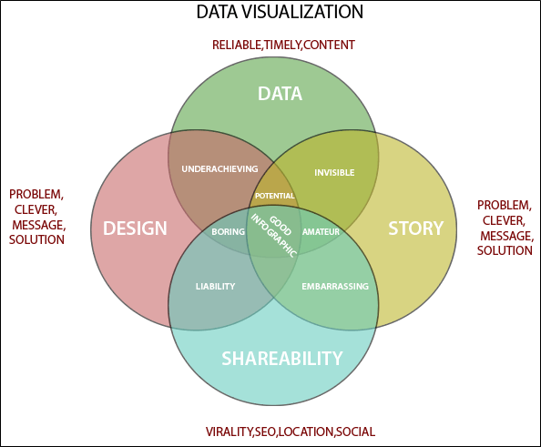

* To craft an effective data visualization, you need to start with clean data that is well-sourced and complete. After the data is ready to visualize, you need to pick the right chart.
* After you have decided the chart type, you need to design and customize your visualization to your liking. Simplicity is essential - you don't want to add any elements that distract from the data.
* Data visualization is important because of the processing of information in human brains. Using graphs and charts to visualize a large amount of the complex data sets is more comfortable in comparison to studying the spreadsheet and reports.
* Data visualization is an easy and quick way to convey concepts universally. You can experiment with a different outline by making a slight adjustment.
* **Data visualization have some more specialties such as:**
  + Data visualization can identify areas that need improvement or modifications.
  + Data visualization can clarify which factor influence customer behavior.
  + Data visualization helps you to understand which products to place where.
  + Data visualization can predict sales volumes.
* Why Data Visualization :
  + To make easier in understand and remember.
  + To discover unknown facts, outliers, and trends.
  + To visualize relationships and patterns quickly.
  + To ask a better question and make better decisions.
  + To competitive analyze.
  + To improve insights.
* Top 10 Data Visualization Tools :
  + Tableau
  + Infogram
  + Datawrapper
  + Chartblocks
  + Plotly
  + Raw
  + Visual.ly
  + D3.js
  + Ember Charts
  + NVD3

1. **Tableau Tools**

A list of Tableau tools:

* Tableau Desktop
* Tableau Public
* Tableau Online
* Tableau Server
* Tableau Reader

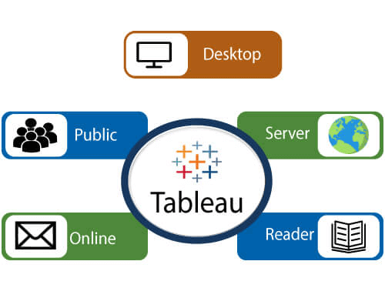

**Data analytics in Tableau is classified into two parts:-**

1. **Developer Tools:-** The Tableau tools which are used for development such as the creation of charts, dashboards, report generation and visualization are known as developer's tools. Tableau Desktop and the Tableau Public, are the example of this type.
2. **Sharing Tools:-** The role of these tools are sharing the reports, visualizations, and dashboards that were created using the developer tools. The Tableau tools that fall into this category are Tableau Server, Tableau Online, and Tableau Reader.

## Tableau Desktop

Tableau Desktop has a rich feature set and allows us to code and customize reports. Right from creating the reports, charts to blending them all to form a dashboard, all the necessary work is created in Tableau Desktop.

For live data analysis, Tableau Desktop establish connectivity between the Data Warehouse and other various types of files. The dashboards and the workbooks created here can be either shared locally or publicly.

Based on the connectivity to the publishing option and data sources, Tableau Desktop is also classified into two parts-

* **Tableau Desktop Personal:-** The personal version of the Tableau desktop keeps the workbook private, and the access is limited. The workbooks can't be published online. So, it should be distributed either offline or in Tableau public.
* **Tableau Desktop Professional:-** It is similar to Tableau desktop. The main difference is that the workbooks created in the Tableau desktop can be published online or in Tableau server. In the professional version, there is full access to all sorts datatypes. It is best for those who want to publish their workbook in Tableau server.

## Tableau Public

This Tableau version is specially built for cost-effective users. The word '**Public**' means that the created workbooks cannot be saved locally. They should be kept on the Tableau's public cloud, which can be accessed and viewed by anyone.

There is no privacy of the files saved on the cloud, so anyone can access and download the same data. This version is the best for them who want to share their data with the general public and for the individuals who want to learn Tableau.

## Tableau Online

Its functionality is similar to the tableau server, but data is stored on the servers that hosted on the cloud, which is maintained by the Tableau group.

There is no storage limit on the data which is published in the Tableau Online. Tableau Online creates a direct link over 40 data sources who are hosted in the cloud such as the **Hive, MySQL, Spark SQL, Amazon Aurora**, and many more.

To be published, both Tableau Server and Tableau online require the workbooks that are created by Tableau Desktop. Data that flow from the web applications say Tableau Server and Tableau Online also support **Google Analytics** and **Salesforce.com**.

## Tableau Server

The software is correctly used to share the workbooks, visualizations, which is created in the Tableau Desktop application over the organization. To share dashboards in the Tableau Server, you should first publish your workbook in the Tableau Desktop. Once the workbook has been uploaded to the server, it will be accessible only to the authorized users.

It's not necessary that the authorized users have the Tableau Server installed on their machine. They only require the login credentials by which they can check reports by the web browser. The security is very high in Tableau server, and it is beneficial for quick and effective sharing of data.

The admin of the organization has full control over the server. The organization maintains the hardware and the software.

## Tableau Reader

Tableau Reader is a free tool which allows us to view the visualizations and workbooks, which is created using Tableau Desktop or Tableau Public. The data can be filtered, but modifications and editing are restricted. There is no security in Tableau Reader as anyone can view workbook using Tableau Reader.

If you want to share the dashboards which are created by you, the receiver should have Tableau Reader to view the document.

1. **Tableau Desktop Installation**

**Tableau is available in two ways:-**

* Tableau Public (Free)
* Tableau Desktop (Commercial)

Here is a comparison between the Tableau Public and Tableau Desktop

**Tableau Public**

* Tableau Public is a free and open-source.
* Tableau public data source can connect to Excel and Text files.
* Tableau public can be installed on Window and Mac operating system.
* Data and Visualizations are not secured in the Tableau public because it is available in public.
* In Tableau public, data cannot be obtained from different data sources as it is limited to connect only Excel and Text files.
* Tableau public uses the details at Personal level.

**Tableau Desktop**

* Tableau Desktop is a paid source, personal edition- $35 per month and professional edition- $70 per month.
* Tableau desktop data source can connect to any data source file, including databases, web applications, and more.
* Tableau desktop can also install on Window and Mac operating system.
* Data and Visualization are secured in Tableau desktop.
* In Tableau desktop, data can extract from various data sources and stored as Tableau extract file.
* Tableau desktop uses the details at Professional and Enterprise level.

**Lets install the Tableau Desktop on Window machine and go through step by step:-**

**Step1:-** Go to <https://www.tableau.com/products/desktop> on your Web browser.

**Step2:-** Click on the **'Try Now'** button.

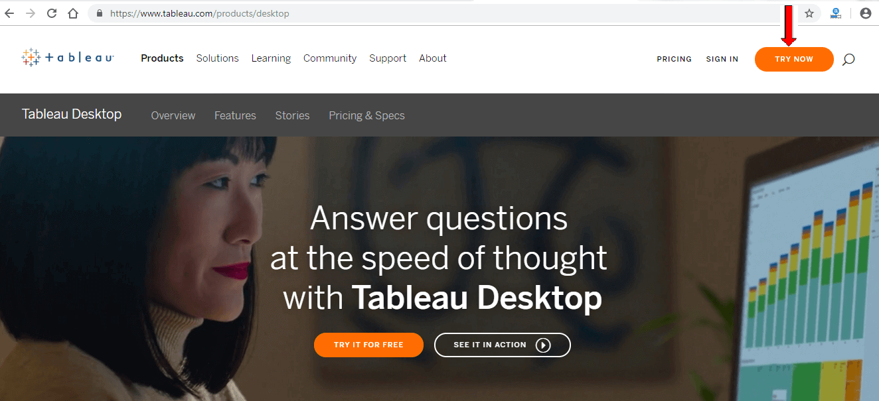

**Step3:-** Now, enter your **Email id** and click on the **'Download Free Trial'** button.

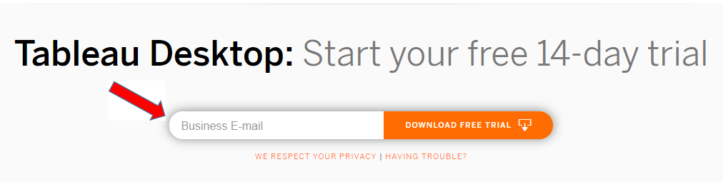

**Step4:-** This will start downloading the .exe File for window machine by default.

**Step5:-** Open the download file, and click on the **'Run'** button.

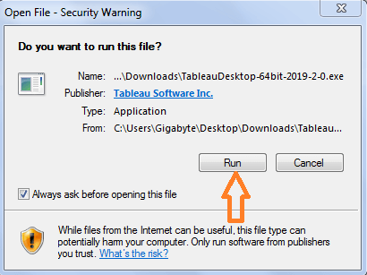

**Step6:-** Accept the terms and condition and click on **'Install'** button.

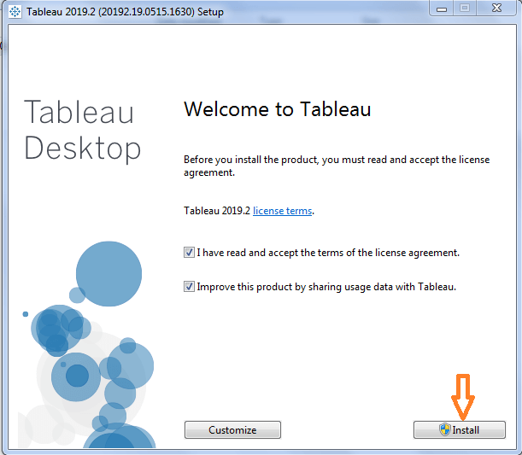

**Step7:-** A pop message will be shown on the screen to get the approval of the administrator to install the Tableau software. Click on **'yes'** to approve it than installation will be started.

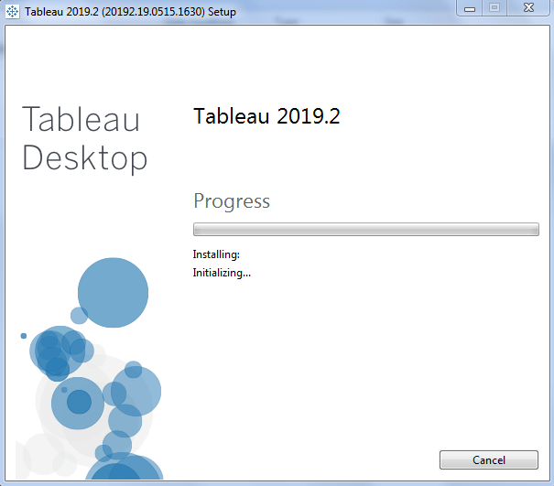

**Step8:-** Once the installation is completed, then open the Tableau desktop software.

**Step9:-** In the registration window

1. Click on Activate Tableau and fill your complete details.
2. Click on start trial now.

**Step10:-** Wait for complete registration.

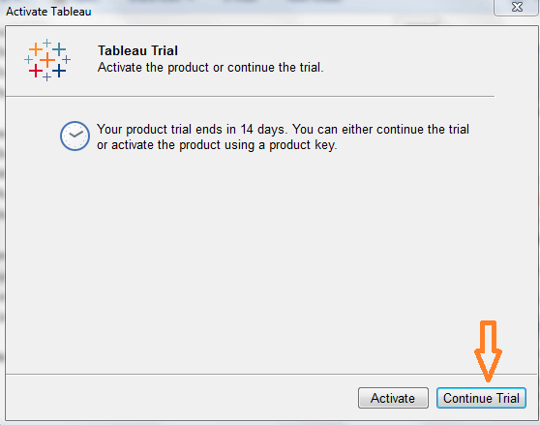

**Step11:-** Start screen of the Tableau Desktop.

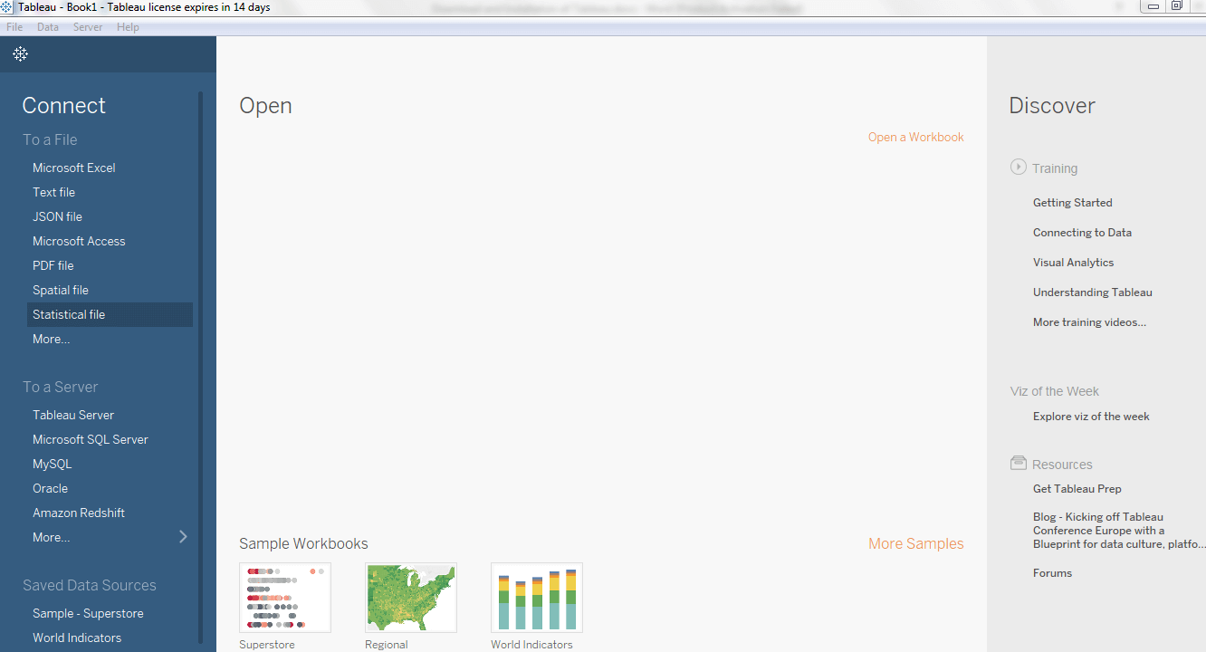

Now, you are all set to use your Tableau desktop on your window machine.

1. **Business Intelligence Tools**

Business Intelligence (BI) tools are software applications that help organizations collect, analyze, and present business data to support better decision-making. These tools facilitate the transformation of raw data into meaningful and actionable insights, enabling businesses to make informed strategic decisions. BI tools typically include features for data visualization, reporting, dashboards, and analytics.

Here are some key components and functionalities of business intelligence tools:

* **Data Integration:** BI tools gather data from various sources, including databases, spreadsheets, and other data repositories. They integrate and consolidate this data to provide a unified view.
* **Data Analysis and Reporting:** BI tools enable users to analyze data through various methods such as ad-hoc querying, multidimensional analysis, and statistical analysis. They also offer reporting capabilities to create standardized reports.
* **Data Visualization:** Visualization is a crucial aspect of BI tools. They use charts, graphs, and other visual elements to represent complex data sets in an easy-to-understand format, helping users identify trends, patterns, and outliers.
* **Dashboards:** BI tools often provide customizable dashboards that allow users to monitor key performance indicators (KPIs) and metrics in real-time. Dashboards provide a consolidated view of important business information.
* **OLAP (Online Analytical Processing):** BI tools leverage OLAP technology to enable users to interactively analyze multidimensional data. This allows for a more dynamic and flexible exploration of data.
* **Predictive Analytics:** Some advanced BI tools incorporate predictive analytics to forecast future trends based on historical data, enabling businesses to anticipate opportunities and challenges.
* **Mobile BI:** Many modern BI tools offer mobile capabilities, allowing users to access and interact with business data on the go through smartphones and tablets.
* **Data Mining:** BI tools may include data mining functionalities to discover hidden patterns, relationships, and insights within large datasets.

Examples of popular Business Intelligence tools include:

* **Tableau:** Known for its powerful data visualization capabilities, Tableau allows users to create interactive and shareable dashboards.
* **Microsoft Power BI:** A comprehensive BI platform by Microsoft, Power BI offers data visualization, self-service analytics, and collaboration features.
* **QlikView/Qlik Sense:** Qlik's associative data model enables users to explore and analyze data dynamically, fostering a more intuitive understanding of information.
* **SAP BusinessObjects:** SAP provides a suite of BI tools, including Crystal Reports and Web Intelligence, to support reporting, analysis, and visualization.
* **IBM Cognos Analytics:** IBM's BI platform includes tools for reporting, dashboards, and analytics, helping organizations make data-driven decisions.
* **Looker:** Looker is known for its data exploration and collaboration features, providing a platform for creating and sharing data models.

These tools cater to various business needs, and the choice of a specific BI tool often depends on factors such as the organization's size, industry, data complexity, and user requirements.

**UNIT 2 : Data Visualization using Tableau**

1. **Visualizations**

Tableau is a powerful data visualization tool that allows users to create interactive and shareable dashboards. Below, is the step-by-step guide on how to create a basic data visualization using Tableau:

**Step 1: Connect to Data :** Open Tableau and connect to your data source. Tableau supports various data sources like Excel, CSV, databases, and more.Once connected, you'll see the data source tab where you can preview your data.

**Step 2: Understand the Data :**Explore your dataset. Understand the fields, data types, and relationships between different columns.

**Step 3: Build a Simple Visualization :**Drag and drop a dimension or measure from the Data pane to the Rows or Columns shelf. For example, drag "Sales" to Columns.Tableau will automatically create a default view, like a bar chart or line chart.

**Step 4: Enhance the Visualization:**

* Customize your chart:
* Click on the drop-down arrow next to a field to access more options.
* Use the Marks card to change the chart type, color, size, and other attributes.
* Drag additional dimensions or measures to the Rows or Columns shelf to add more detail.

**Step 5: Create Filters :** Drag a field to the Filters shelf to create filters. You can filter data based on specific criteria like date range, categories, etc.

**Step 6: Build a Dashboard :** Click on the "Dashboard" tab at the bottom of the screen.Drag sheets or objects onto the dashboard canvas.Arrange and resize components to create an interactive dashboard.

**Step 7: Add Interactivity :** Use the dashboard actions to add interactivity. For example, you can make one chart filter another when you select specific data points.

**Step 8: Save and Share :** Save your Tableau workbook. You can share your visualization by publishing it to Tableau Server or Tableau Online, or you can export it as an image or PDF.

**Step 9: Explore Advanced Features :** Explore Tableau's advanced features like calculated fields, parameters, and reference lines to add more depth to your analysis.Consider using Tableau's mapping features for geographical data.

**Step 10: Learn and Iterate :** Explore Tableau's extensive documentation and online resources to learn more about advanced features and best practices.Iterate on your visualization based on feedback and insights gained.

Remember, Tableau offers a wide range of features, and this guide provides a basic introduction. The more you explore and practice, the more proficient you'll become in creating insightful and interactive visualizations with Tableau.

1. **Functions in Tableau : Join and Union, Sort, Set**

In Tableau, you can perform various data manipulation operations, including joins, unions, sorting, and set operations. Let's explore each of these concepts:

**1. Join in Tableau:** A join is used to combine data from two or more tables based on common fields. Here are the steps to perform a join:

1. Connect to your data source.
2. Drag the tables you want to join from the left pane to the Data Source tab.
3. Define the join conditions by dragging a field from one table to the corresponding field in the other table.
4. Choose the type of join (Inner Join, Left Join, Right Join, Full Outer Join) and click "OK."

**2. Union in Tableau:** A union is used to combine data from multiple tables with the same structure. Here's how you can perform a union:

1. Connect to your data source.
2. Drag the tables you want to union from the left pane to the Data Source tab.
3. Click on one of the tables, and then hold down the Ctrl key (Command key on Mac) and click on the additional tables.
4. Right-click and choose "Union."

**3. Sorting in Tableau:** Sorting is essential for presenting data in a meaningful way. You can sort data in Tableau by following these steps:

1. On a worksheet, right-click on the field you want to sort.
2. Choose the "Sort" option and select either ascending or descending order.
3. You can also choose to sort manually or by a specific field.

**4. Set in Tableau:** A set is a custom subset of data created based on specific conditions. Here's how you can create a set:

1. Drag a field to the Rows or Columns shelf.
2. Right-click on a data point in the view, and choose "Create Set."
3. Define the conditions for the set, and click "OK."
4. You can use sets in calculations, filters, and visualizations.

**Additional Tips:**

**Combined Fields:** You can create calculated fields to concatenate or manipulate data as needed.

**Aliases:** Customize the display names of fields using aliases for better readability.

**Parameters:** Use parameters to create dynamic and interactive dashboards by allowing users to change certain aspects of the visualization.

These are just a few examples of data manipulation capabilities in Tableau. The tool provides a robust set of features for exploring, analyzing, and visualizing data, making it a powerful choice for business intelligence and data visualization tasks.

1. **Forecasting, Highlighting, Device Designer**

**Forecasting in Tableau**

Tableau does not have built-in forecasting capabilities as advanced as those in dedicated statistical software. However, you can use some techniques and features within Tableau to create simple forecasts or integrate Tableau with external tools for more advanced forecasting. Here are some approaches:

### 1. Trend Lines and Reference Lines:

Tableau provides trend lines that can be added to visualizations to show the general trend in the data. This can be a simple way to create a visual representation of a forecast.

1. **Drag a field to the Rows or Columns shelf.**
2. **Right-click on the axis and select "Add Trend Line."**
3. **Choose the desired trend line type (linear, exponential, etc.).**

Reference lines can also be used to extend a line beyond the existing data points, providing a basic visual forecast.

### 2. Forecasting with Analytics Extensions:

Tableau integrates with R and Python through Analytics Extensions, allowing you to leverage the forecasting capabilities of these languages.

1. **Enable Analytics Extensions:**
   * Go to Help > Settings and Performance > Manage External Service Connection.
   * Enable the R or Python server connection.
2. **Create a Calculated Field:**
   * Write a calculated field using R or Python code to perform forecasting.

### 3. Use External Forecasting Tools:

You can use dedicated forecasting tools or statistical software to create forecasts and then import the results into Tableau. This is especially useful for more complex forecasting models.

1. **Create Forecasts in External Tool**
   * Use tools like R, Python (with libraries like scikit-learn or statsmodels), or specialized forecasting software.
2. **Import Forecast Results into Tableau:**
   * Bring the forecasted results into Tableau as a data source.

### 4. Explore Tableau Extensions:

Tableau extensions created by third-party developers may provide additional forecasting capabilities. Explore the Tableau Extension Gallery for any extensions that offer forecasting features.Remember that the appropriateness of each method depends on the complexity of your data and the accuracy required for your forecast. For advanced forecasting, statistical software like R or Python may be more suitable, while Tableau can be used for visualizing and communicating the results.

**Highlighting in Tableau**

Highlighting in Tableau is a feature that allows you to emphasize specific data points or subsets of data in your visualizations. Highlighting helps draw attention to certain elements and supports a more focused analysis. Here's how you can use highlighting in Tableau:

**Highlighting in Worksheets:**

* + - 1. **Drag and Drop:**

On a worksheet, you can highlight specific data points by dragging and dropping fields onto the "Color" shelf. This changes the color of the data points based on the selected field.

* + - 1. **Use the Highlighter:**
         * Select the "Highlight" option from the toolbar.
* Click on a data point, and Tableau will highlight related data points based on the chosen field.

**Highlighting in Dashboards :**

1. **Dashboard Actions :** 
   * Go to a dashboard by clicking on the "Dashboard" tab.
   * Under the Dashboard menu, select "Actions."
   * Create a new highlight action.
   * Choose the source sheet, target sheet, and the field to be used for highlighting.
2. **URL Actions:**
   * You can use URL actions to create hyperlinks that highlight specific data points.
   * Define a calculated field that generates a URL based on the selected data point.
   * Create a URL action to open the calculated URL.

### Highlighting with Sets:

1. **Create a Set:**
   * Right-click on a data point and choose "Create Set."
   * Define the set based on specific conditions.
   * The set appears in the Sets pane.
2. **Use the Set in Highlighting:**
   * Drag the set to the "Color" shelf or use it as a filter.
   * The set will highlight the relevant data points.

**Device Designer in Tableau**

Tableau's Device Designer is a feature that allows you to create dashboards optimized for different devices and screen sizes. It helps you design responsive dashboards that adapt to various devices, such as desktops, tablets, and smartphones. Below are the key steps to use the Device Designer in Tableau:

### How to Use Device Designer in Tableau:

1. **Open a Dashboard:**
   * Create or open a dashboard in Tableau Desktop.
2. **Access Device Designer:**
   * Go to the "Dashboard" menu in the top menu bar.
   * Select "Layout" and then choose "Device Designer."
3. **Add Devices:**
   * In the Device Designer window, you'll see a list of predefined devices and layouts.
   * Add devices by clicking the "Add" button and selecting the devices you want to design for (e.g., Desktop, Tablet, Phone).
4. **Design for Each Device:**
   * Click on each device to design the layout specifically for that device.
   * Resize and rearrange sheets, objects, and containers to optimize the layout for the selected device.
5. **Show or Hide Sheets and Objects:**
   * You can show or hide specific sheets and objects for each device. This allows you to tailor the content based on the available screen space.
6. **Test the Layout:**
   * Use the "Preview" option to test how your dashboard looks on different devices.
   * Adjust the layout until it looks optimal for each device.
7. **Save Changes:**
   * Once you're satisfied with the layout for each device, click "OK" to save your changes and exit the Device Designer.
8. **Publish the Dashboard:**
   * If you're working on a Tableau Server or Tableau Online, you can publish the dashboard to share it with others.